NAME:KHAN ABDUL FAROOQUE WASEEM
PRN:202501080023
GITHUB LINK:
https://github.com/Khan-AFarooque/Practicals
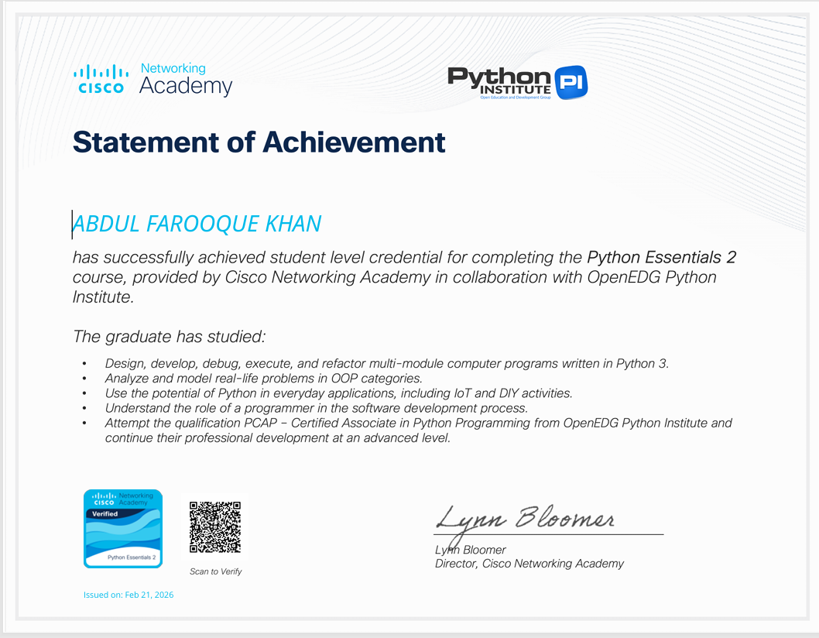
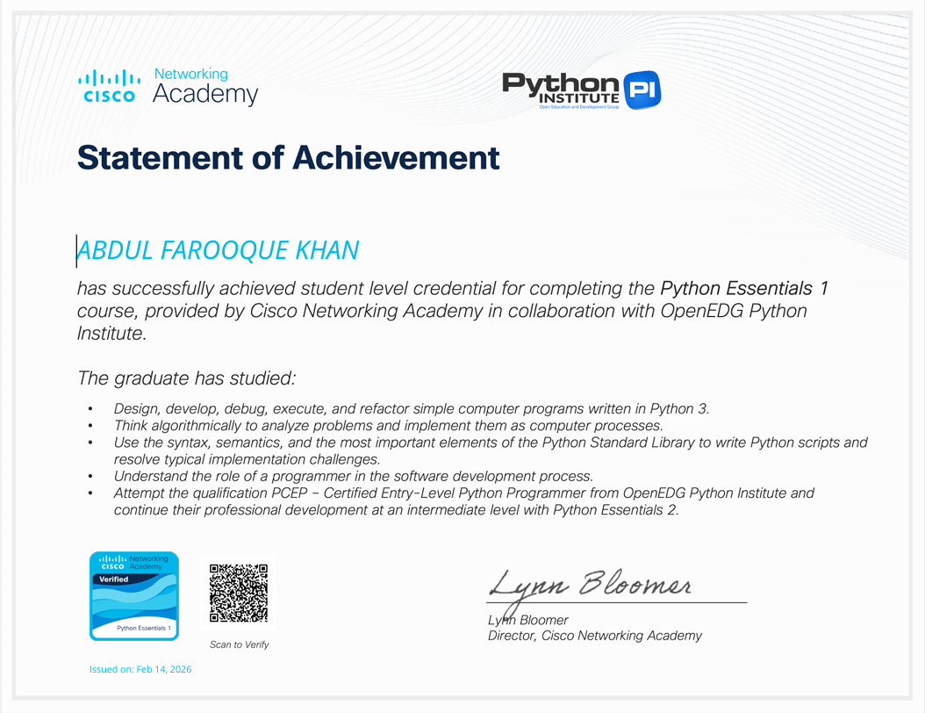
YOUTUBE LINK:
https://youtube.com/@codingcoaching?si=a2b2p-BjSscSXudm

